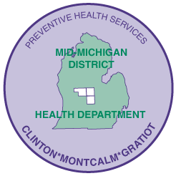
MID-MICHIGAN DISTRICT HEALTH DEPARTMENT
Your public health team, connecting with our communities to achieve healthier outcomes

Submitted by: Leslie Kinnee, Public Information Officer
615 N. State St., Stanton, MI 48888-9702
989-831-3669, lkinnee@mmdhd.org

www.mmdhd.org

FOR IMMEDIATE RELEASE: 5-12-17

Program helps kids with special needs

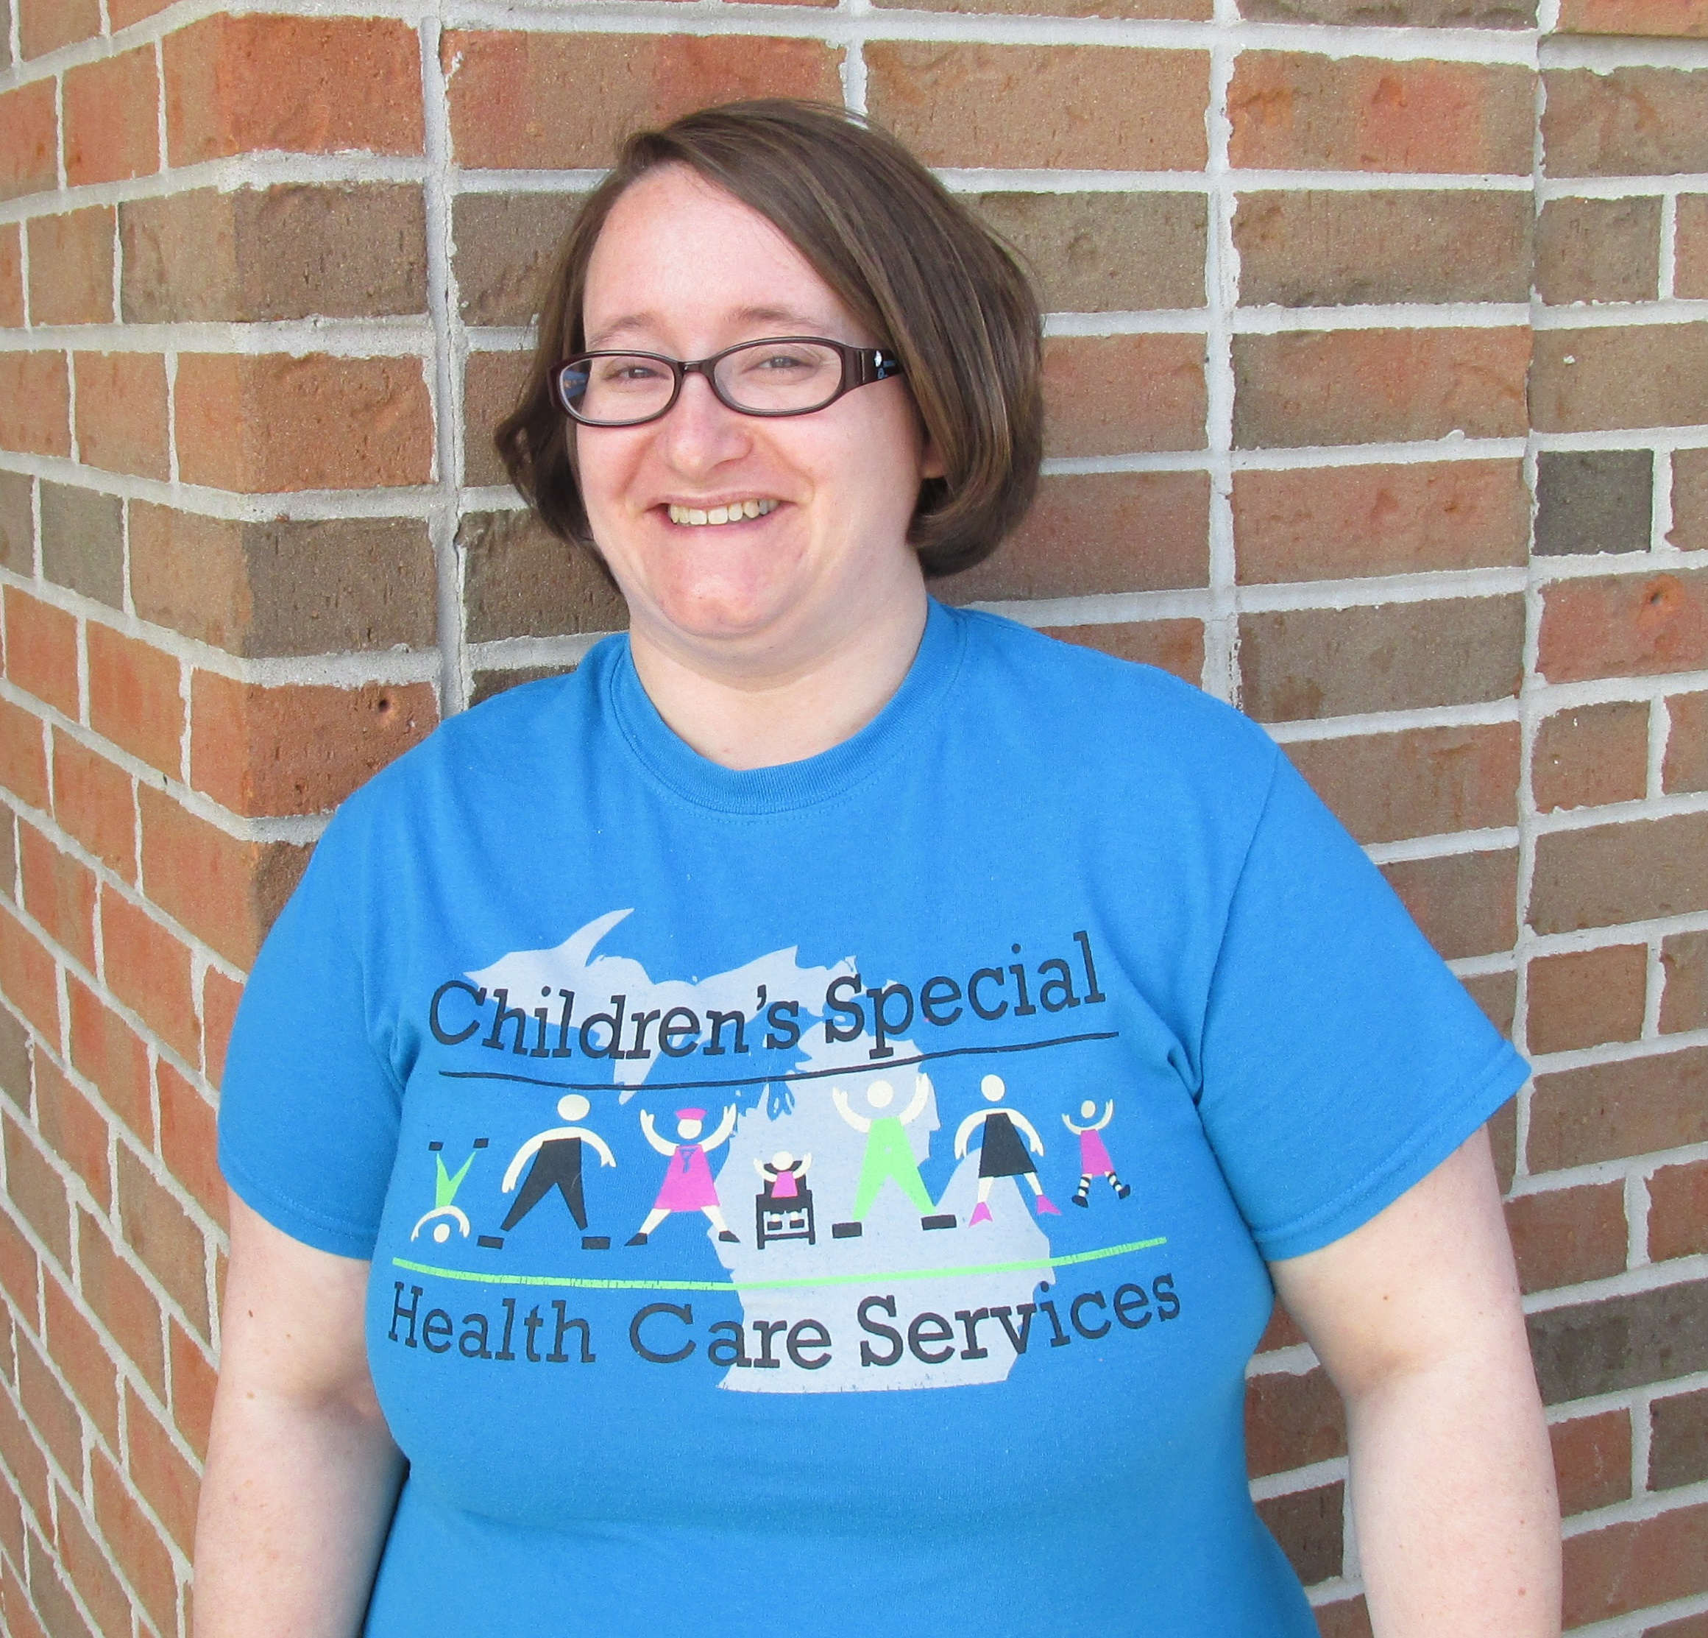
Ithaca, Stanton, St. Johns- Amanda Shaffer and her husband, Willis, have four beautiful children, all of whom have various types of special needs, including scoliosis, chronic lung disease, cerebral palsy, autism, asthma, sleep apnea, oppositional defiant disorder, and attention deficit disorder, just to name a few.

Having a child with special needs can be overwhelming for any family, but having four kids with serious health issues can leave a family in emotional and financial ruin. Luckily for the Shaffers, they have been blessed with an outpouring of support from family and friends, who lend a hand when they can, a shoulder to cry on, or a listening ear.

Amanda also credits a little-known program for helping her and Willis keep their sanity and stay out of bankruptcy: Children’s Special Health Care Services
Amanda Shaffer, Parent Liaison for (CSHCS). The program covers over 2,600 health care diagnoses and is for Children’s Special Health Care Services children from birth to age 21, and some adults with certain conditions.

The program assists the family with things they wouldn’t be able to afford otherwise, like medication and equipment costs. It also helps ease the family’s financial burden by helping to cover co-pays, hospital stays and travel costs when visiting out-of-town doctors. In addition, CSHCS helps with specialty medical bills and deductibles, finding specialty services and providers, coordinating services from multiple providers, locating support groups, identifying community-based services to help care for the child at home, and much more.

“We simply would not be able to treat our kids without CSHCS,” said Amanda. “The program has given us something invaluable- peace of mind. It allows us to concentrate more on our children and less on medical bills and related expenses.”

Helping other families in the same type of situation is a passion of Amanda’s, and as Parent Liaison for the program, something she’s proud of.

“As CSHCS Parent Liaison, I have the great pleasure of working with families just like my own. I’m the point of contact for moms and dads looking for answers. I help them through the tough times and support parents new to the program. We share similar experiences, and that helps me connect with them on a deeper level. I understand what they’re going through, where they’ve been, and what they need.”

It’s her mission to make as many eligible families aware of the program and encourages them to apply, regardless of how much money they make, or if they are insured. That’s because the child’s medical condition, not family income, determines if they qualify. Families with higher incomes, like the Shaffer’s, may be asked to pay a small yearly fee, but she says it’s well worth it in the long run.
-more-

2- Children’s Special Health Care Services

Amanda’s working hard to support every member of special needs families and is especially excited about two opportunities coming up.

All families currently enrolled in the program are reminded of the 4th annual CSHCS Family Fun Day Picnic, being held on
May 20 at the Ithaca High School Football Complex from 11:30 a.m. to 2:30 p.m. This year’s festivities will include crafts, games, a photo booth, door prizes, sensory activities, pizza and community resource information. Those who think their child might qualify for CSHCS, but just aren’t sure, are also invited to attend. Staff will be on hand to answer questions and help determine eligibility.

Shaffer is also coordinating Sibshops, which are fun events filled with games and laughter, just for siblings ages 8 to 13. It’s a great place to talk about the good and not-so-good aspects of having a sibling with special needs with others who “get it.”
Amanda said it’s important to acknowledge that being a brother or sister of a person with special needs is for some a good thing, others a not-so-good thing, and for many, somewhere in-between, and that it’s okay to have those feelings.

The other thing Shaffer wants clients to know is that she and the rest of the health department’s CSHCS staff really care about them and work hard to help families achieve the best possible outcome.

If you think your child may qualify for Children’s Special Health Care Services, have questions about the picnic, or would like to sign your kids up for a Sibshop, call:

Clinton County: 989-227-3121
Gratiot County: 989-875-1004
Montcalm County: 989-831-3643

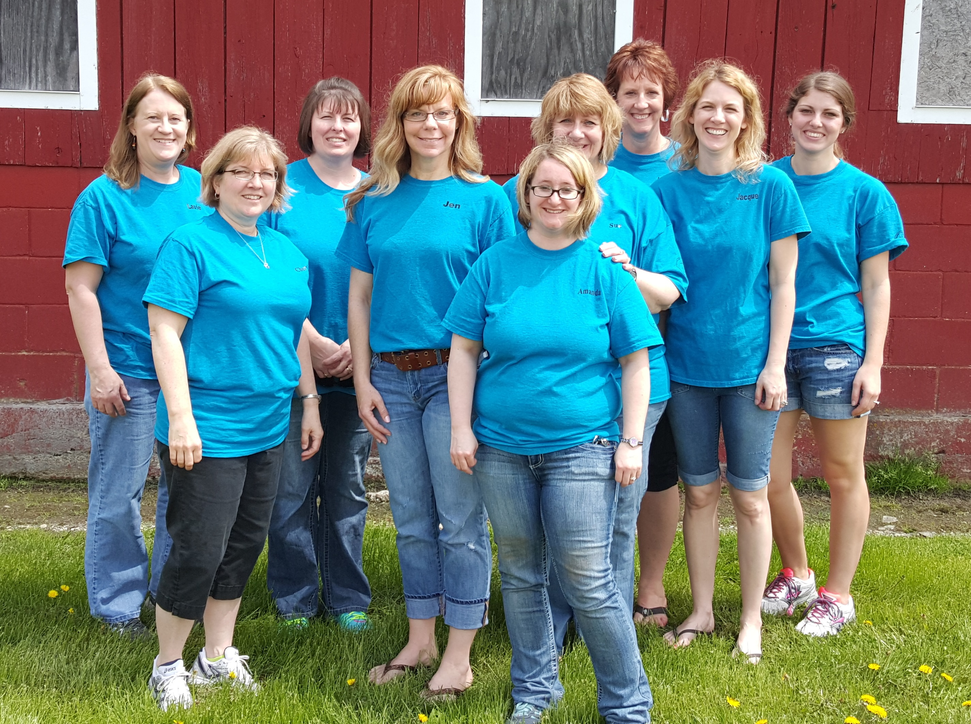
Children’s Special Health Care Services staff, back row: Laurie Finn,
Peggy Fox, Laureen Simon, Intern Hanna Hengesbach. Middle row:
Cheryl Thelen, Jennifer Stratton, Sue Corrigan, Jacque Strack.
Front row: Amanda Shaffer. Missing: Jamie Sawdy and Wendy Currie.

Mid-Michigan District Health Department serves the residents of Clinton, Gratiot and Montcalm Counties.

###

