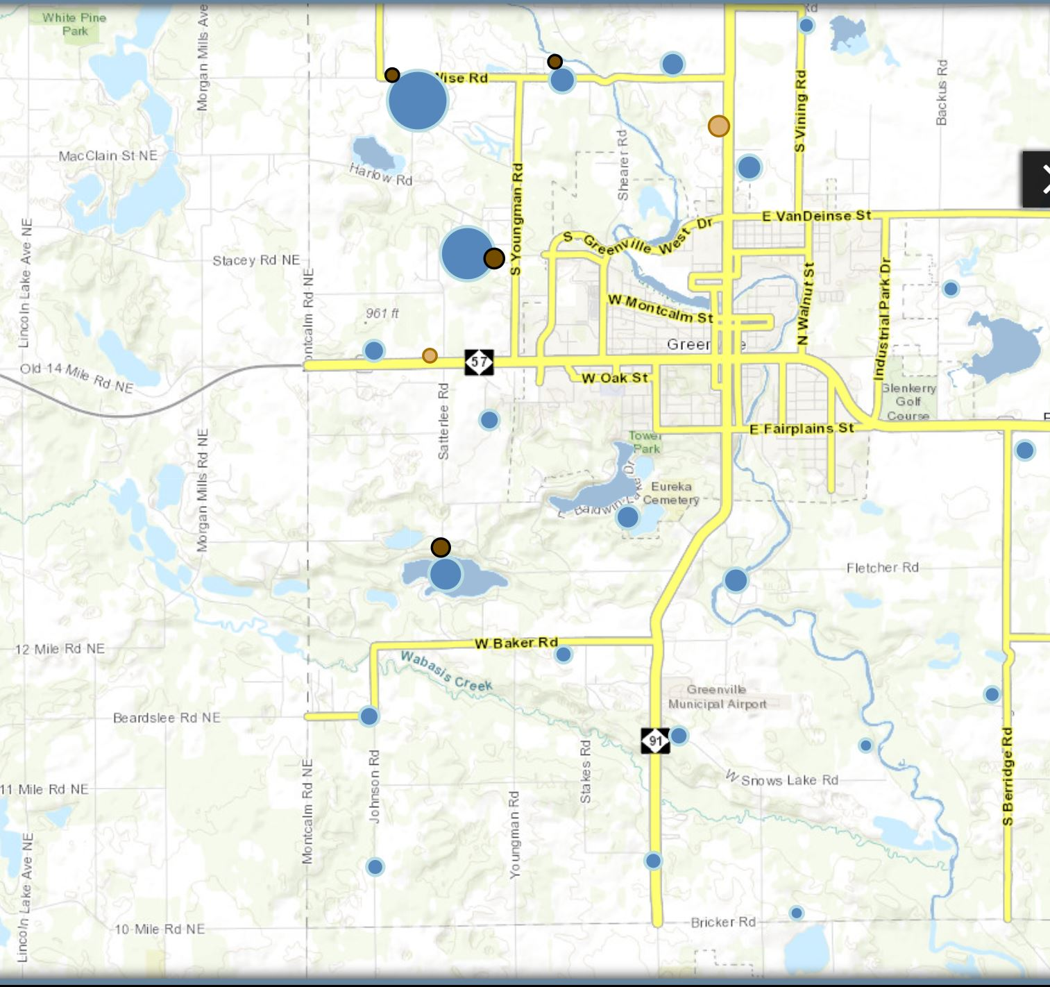

Montcalm Area to be sprayed.