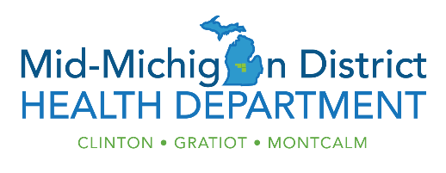

COVID-19 Vaccination Scheduling Instructions

If you live or work in Clinton, Gratiot or Montcalm Counties and are 18 years of age or older, you are eligible to get vaccinated at Mid-Michigan District Health Department and may make an appointment.

Important Information- please read before scheduling an appointment:
- If you are not able to get an appointment this time, there will be another opportunity.
- When the calendar pops up, the available date is highlighted. If it is grayed out, the clinic is full.
- Fields marked with a red * must be filled out. You can skip all other fields.
- The vaccine is free. We are not billing insurance. You do not need to enter your insurance information.
- Multiple people can be attempting to register for the same appointment at the same time. Whoever hits “submit” first gets the time slot. If you receive the message “this time slot is no longer available,” you will need to select a different time.
- If you successfully schedule an appointment, you will receive an email confirming the date, time and location of your appointment. Make sure to check your spam or junk folder.
- Please do not call to verify your appointment. If you received the verification email, you have successfully scheduled an appointment.
- If you are not able to make your appointment, please let us know so that we can give your dose to someone else. You may cancel or reschedule your appointment 12 hours prior to the clinic using your verification email. After that, you can call our office at 989-831-5237 (option 2).
- Please do not arrive early for your appointment.
- You will need to wait 15-30 minutes after you get vaccinated to make sure you don’t have a reaction. The entire process takes 30-45 minutes.

