Communicable Disease Reporting Handbook
How to Report Student Illnesses

Mid-Michigan District Health Department
Clinton Branch Office Gratiot Branch Office Montcalm Branch Office
Becky Stoddard, RN Lisa Mikesell, RN Jennifer Johnson, RN
1307 E. Townsend Rd. 151 Commerce Dr. 615 N. State St., Ste. 1
St. Johns, MI 48879 Ithaca, MI 48847 Stanton, MI 48888
Ph. 989-227-3111 Ph. 989-875-1019 Ph. 989-831-3615
Cell 616-302-6435 Cell 616-302-6230 Cell 989-763-2366
Fax 989-227-3126 Fax 989-875-1032 Fax 989-831-3666
bstoddard@mmdhd.org lmikesell@mmdhd.org jjohnson@mmdhd.org
24-7 Pager 989-276-0260
August 2, 2021
What is a Communicable Disease?

A communicable disease (CD) is an infectious illness which can result from either direct contact with an infected individual, an infected individual’s discharges (such as mucous, saliva, feces, or body fluids), or by indirect contact (for example, through a mosquito bite).

Why do Schools & Childcare Centers Have to Report Communicable Diseases?

Michigan law requires that schools and childcare centers report occurrence of any communicable disease to the local health department on a weekly basis. Physicians, clinical laboratories, primary and secondary schools, childcare centers, and camps are required to report occurrence or suspected occurrence of any disease, condition or infection as identified in the Michigan Communicable Disease Rules (Act NO. 368 of the Public Acts of 1978-Communicable Disease Reporting).
Communicable disease reports from all of the reporting entities are reviewed by the communicable disease nursing staff at the Mid-Michigan District Health Department (MMDHD) to look at trends of illnesses in the county. It is important for schools to report on a weekly basis for a number of reasons, but mostly:
- To identify outbreaks and epidemics
- To enable preventive treatment and/or education
- To ensure the safety of the educational environment in your school
- To target prevention programs, identify care needs, and allocate resources efficiently
- To facilitate research
- To assist with local, state, national, and international disease surveillance efforts

Collecting Timely and Accurate Information

Timely and accurate disease reporting is essential to the health of all residents of Clinton Gratiot and Montcalm Counties. It is extremely important that all schools in Clinton, Gratiot and Montcalm Counties comply with reporting requirements. In order to do this the following steps should be put in place:
- Designate one person at each school to collect accurate communicable disease data daily
- Train an alternate person to collect and report communicable disease data in case the primary person is absent
- Submit communicable disease reports to the MMDHD every Friday (recommended), but by Monday at Midnight (even if there are no diseases to report)
- Notify the MMDHD immediately when you become aware of an illness that is listed on the “List of Reportable Diseases” or if the school is closed due to illness
- Have a consistent manner of questioning parents about the child’s illness
- Educate parents on the importance of reporting illness to schools.

Obtaining Information from Parents
Answering Machine Message and Child Illness Inquiry

In an effort to receive accurate and consistent information from each school, the MMDHD suggests that schools include the following directions in their answering machine message and when questioning a parent about a child’s illness.

- Describe the symptoms of the illness (vomiting, diarrhea, fever, rash, etc.)
- Report the type of illness if known and who identified the illness
- Leave a phone number where the parent/guardian can be reached or an address if there is no phone

Newsletter Information for Parents

The following is an example of what schools could include in their newsletters or other correspondence to parents to make them more aware of the importance of calling in children’s illness and what information is needed:

Important Notice to Parents/Guardians
From the Mid-Michigan District Health Department
Regarding Student Absences
The Mid-Michigan District Health Department is working directly with your child’s school to make Clinton, Gratiot and Montcalm Counties a healthier place to live. Michigan law requires that schools report the occurrence of any communicable diseases to the local health department on a weekly basis. To assist your child’s school in reporting communicable diseases to the health department and preventing disease outbreaks, please be specific when reporting your child’s absence.

When calling in for a child please include the following information:

- A description of the symptoms of the illness (vomiting, fever, rash, diarrhea, etc.)
- The type of illness if known and who identified the illness
- Your telephone number (if no phone, give address)

Your cooperation with the school and the Mid-Michigan District Health Department is greatly appreciated.

List of Reportable Diseases

The following is a list of conditions required to be reported by schools, child-care centers, and camps. School personnel are not expected to be familiar with every disease listed on page 4. However, this list should be available for quick reference whenever there is doubt as to whether a disease should be reported. You may always call the health department to speak with a communicable disease nurse if you have ANY questions about these diseases.
Anaplasma phagocytophilum (Anaplasmosis)  Arboviral encephalitides, neuro‐ and non‐neuroinvasive:  California serogroup, Eastern Equine, Powassan  St. Louis, Western Equine, West Nile  Babesia microti (Babesiosis)  Bacillus anthracis (Anthrax)  Blastomyces dermatitidis (Blastomycosis)  Bordetella pertussis (Pertussis)  Borrelia burgdorferi (Lyme Disease)  Brucella species  Burkholderia mallei (Glanders)  Burkholderia pseudomallei (Melioidosis)  Campylobacter species  Chlamydia trachomatis  Chlamydophila psittaci (Psittacosis)  Clostridium botulinum (Botulism)  Clostridium tetani (Tetanus)  Coccidioides immitis (Coccidioidomycosis)  Corynebacterium diphtheriae (Diphtheria)  Coxiella burnetii (Q Fever)  Cryptosporidium species  Cyclospora species  Dengue virus  Ehrlichia species  Encephalitis  Entamoeba histolytica (Amebiasis)  Escherichia coli, O157:H7  Francisella tularensis (Tularemia)  Giardia species  Guillain‐Barre Syndrome  Haemophilus ducreyi (Chancroid)  Haemophilus influenza  Hantavirus  Hemolytic Uremic Syndrome (HUS)  Hepatitis, viral  Hepatitis A virus  Hepatitis B virus, (HBsAg), especially in pregnant women  Hepatitis C virus  Hepatitis D virus  Hepatitis E virus  Histoplasma capsulatum (Histoplasmosis)  HIV | Influenza virus (Weekly aggregate counts)  Pediatric mortality, report individual cases  Novel Influenza viruses  Kawasaki Disease  Legionella species  Leptospira species  Listeria monocytogenes  Measles virus (Measles/Rubeola)  Meningitis  Mumps virus  Mycobacterium leprae (Leprosy or Hansen’s disease)  Mycobacterium tuberculosis complex (Tuberculosis)  Neisseria gonorrhoeae (Gonorrhea)  Neisseria meningitidis, sterile sites (Meningococcal Disease)  Orthopox viruses (including: Smallpox, Monkeypox)  Plasmodium species (Malaria)  Poliovirus  Prion disease (Including: CJD)  Rabies virus  Rheumatic fever  Rickettsia species (Spotted Fever and Typhus Group)  Rubella virus  Salmonella species  Salmonella typhi (Typhoid Fever)  Severe Acute Respiratory Syndrome (SARS)  Shigella species  Staphylococcus aureus, (MRSA), outbreaks only  Staphylococcus aureus, (VISA/VRSA)  Streptococcus pneumoniae  Streptococcus pyogenes, group A  Streptococcal Toxic Shock Syndrome (STSS)  Toxic Shock Syndrome (non‐Streptococcal)  Treponema pallidum (Syphilis)  Trichinella spiralis (Trichinellosis)  Varicella (Chickenpox)  Vibriosis (Cholera)  Vibrio cholera  Viral Hemorrhagic Fever  Yellow fever virus  Yersinia enterocolitica (Yersiniosis)  Yersinia pestis (Plague)
In the Event of an Actual or Potential Outbreak Situation
The Mid-Michigan District Health Department collects communicable disease reports from health care providers, schools, and childcare centers. The MMDHD reviews the reports to identify disease trends, illnesses and outbreaks in the county.
In the event of an actual or potential outbreak of a serious communicable disease, your district may be contacted to provide information to assist us in the investigation of the disease, and ultimately in the protection of the school community. Your assistance during the beginning critical phases of an investigation is important to its success.
*The Michigan Public Health Code (MCL 333.5111) and administrative rules give local and state health departments the authority and responsibility to investigate cases of disease and suspected transmission. Any information provided by the school is covered under the Michigan Public Health Code in accordance with state law and will not violate FERPA standards. It is extremely important schools maintain confidentiality regarding information shared during a communicable disease investigation.
The Privacy Rule in the Health Insurance Portability and Accountability Act of 1996 (HIPPA) allows for the disclosure of protected health information, without individual client/patient authorization, to public health authorities, who are legally authorized to receive such reports for the purpose of preventing or controlling disease.
An investigator who presents official identification of a local health department or the Michigan Department of Health and Human Services shall be provided with medical and epidemiological information pertaining to any of the following persons on request:
- Individuals who have any condition required to be reported or other condition of public health significance
- Individuals, whether ill or well, who are part of a group in which an unusual occurrence, outbreak, or epidemic has occurred
- Individuals who are not known to have a condition, but whose medical or epidemiological information is needed for investigation into the cause of a condition pf public health importance
- Individuals potentially exposed to a designated condition
Information which may be requested includes, but is not limited to the following:
- Absence history related to current illness
- Name, date of birth, address and telephone number of the ill person
- Name of child’s parent/guardian
- Name of health care provider, if known
- Current immunization information, if available
- List of classmates, teachers, or others who may have been exposed to the disease, with telephone numbers
- Bus route, with telephone numbers
- List of extra-curricular activities student/staff/faculty is active in, with potential need for list of students and staff participants and telephone numbers.
Instructions for Reporting
- During the week, keep track of incoming reports as they are phoned into your building.
- Submit communicable disease reports to MMDHD every Friday (recommended), but by Monday at Midnight (even if there are no diseases to report).
- If a case of ANY of the listed “List of Reportable Diseases” is reported to your school, or if the school is closed due to illness, call the health department IMMEDIATELY at 989-227-3111 in Clinton County, 989-875-1019 in Gratiot County or 989-831-3615 in Montcalm County to speak with the communicable disease nurse.
- If a communicable disease nurse is not available when you call, leave a message with the name of the school, name of student, the type of illness you are reporting, and contact information for the student and their doctor if available.
- You may also call the communicable disease nurse’s cell phone, which is listed on the first page of the handbook
Ways to Report
Online reporting (preferred method):
The website for accessing the online reporting tool is as follows:
Clinton https://communicablediseasereporting.com/clinton.php
Gratiot https://communicablediseasereporting.com/gratiot.php
Montcalm https://communicablediseasereporting.com/montcalm.php

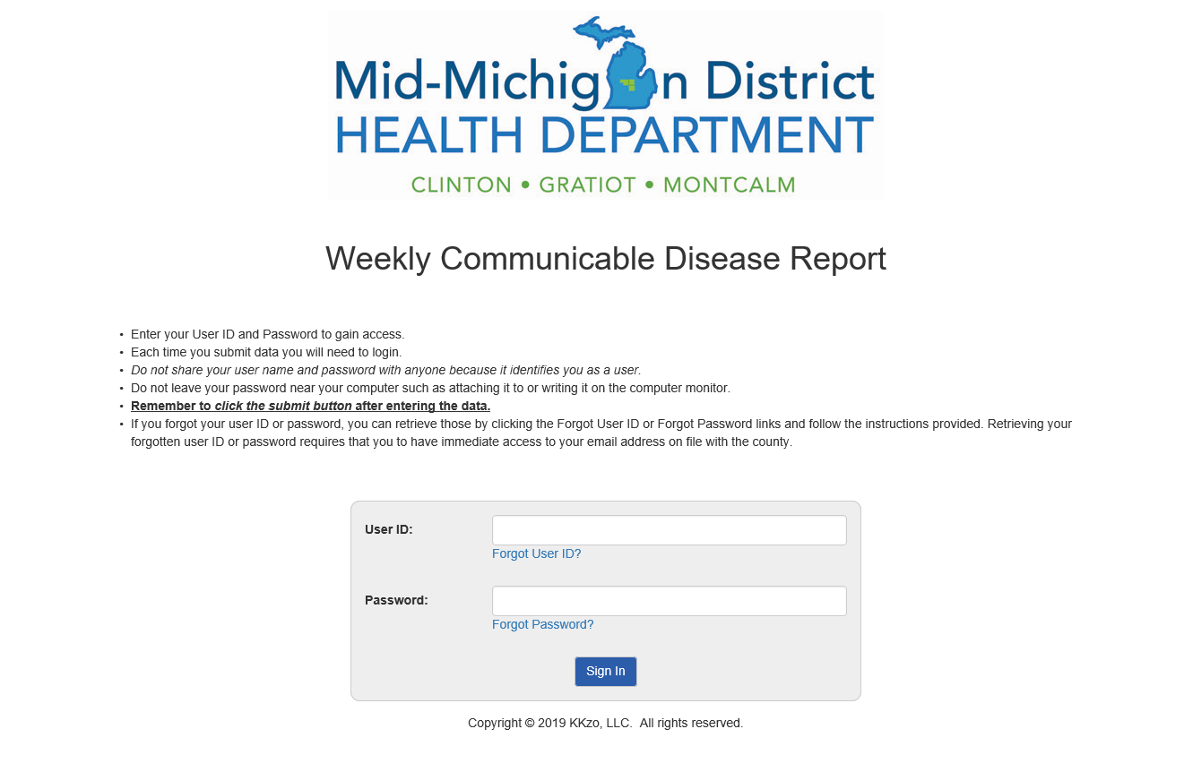
- Above is the login screen for the CD reporting online tool.
- Enter your User ID and Password to gain access.
- Each time you submit data you will need to login.
- If you forgot your user ID or password, you can retrieve those by clicking the Forgot User ID or Forgot Password links and follow the instructions provided.
- Retrieving your forgotten user ID or password requires that you have to have immediate access to your email address on file with the county.
- Do not share your username and password with anyone because it identifies you as a user.
- Do not leave your password near your computer such as attaching it to or writing it on the computer monitor.
- Remember to click the “submit” button after entering the data.
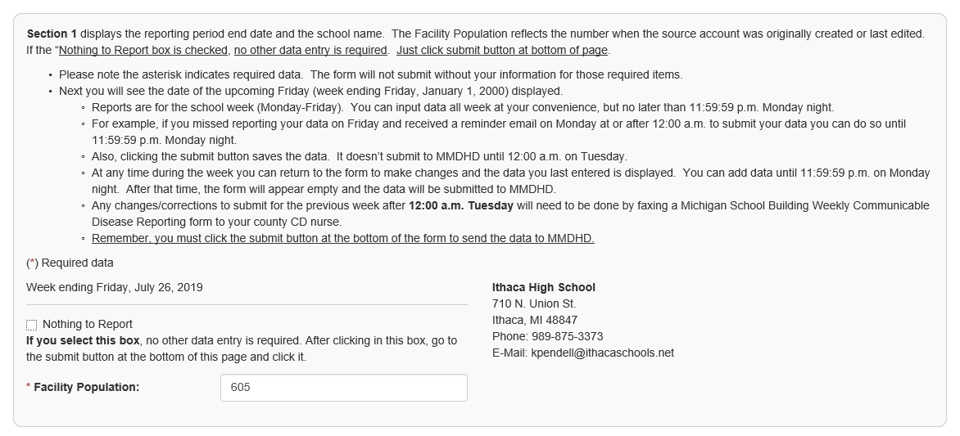
- Section 1 displays the reporting period end date and the school name. The Facility Population reflects the number when the source account was originally created or last edited. If the “Nothing to Report box is checked, no other data entry is required. Just click “submit” button at bottom of page.
  - Please note the asterisk indicates required data. The form will not submit without your information for those required items.
  - Next you will see the date of the upcoming Friday (week ending Friday, January 1, 2000) displayed.
    - Reports are for the school week (Monday-Friday). You can input data all week at your convenience, but no later than 11:59:59 p.m. Monday night.
    - For example, if you missed reporting your data on Friday and received a reminder email on Monday at or after 12:00 a.m. to submit your data you can do so until 11:59:59 p.m. Monday night.
    - Please note: the new reporting week starts 12:00 a.m. Monday and if you have not yet submitted data for last week or need to make edits to the previous week then there will be two dates displayed, make sure to click on the correct date.
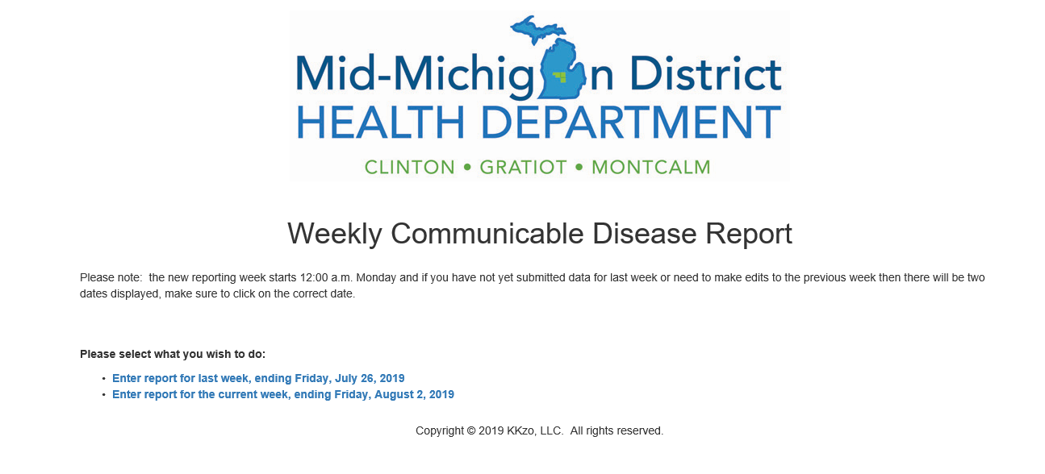
    - Also, clicking the “submit” button saves the data. It doesn’t submit to MMDHD until 12:00 a.m. on Tuesday.
    - At any time during the week you can return to the form to make changes and the data you last entered is displayed. You can add data until 11:59:59 p.m. on Monday night. After that time, the form will appear empty and the data will be submitted to MMDHD.
    - Any changes/corrections to submit for the previous week after 12:00 a.m. Tuesday will need to be done by faxing a Michigan School Building Weekly Communicable Disease Reporting form to your county CD nurse.
  - Remember, you must click the “submit” button at the bottom of the form to send the data to MMDHD.
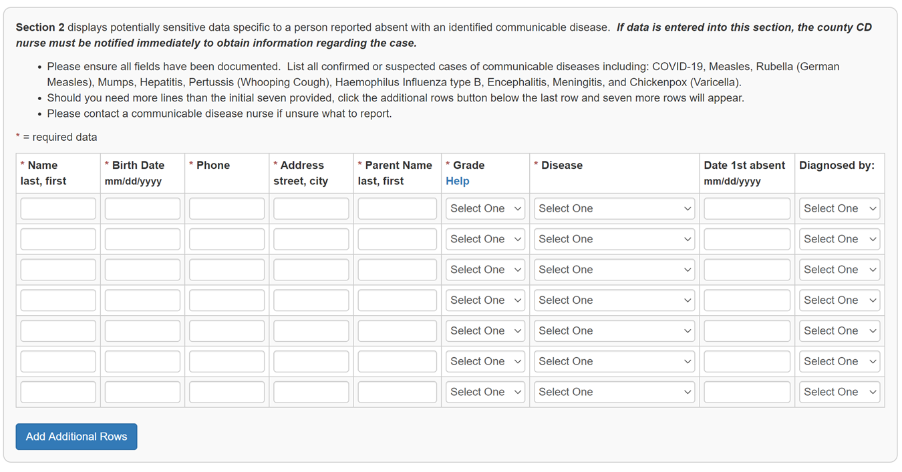
- Section 2 displays potentially sensitive data specific to a person reported absent with an identified communicable disease. If data is entered into this section, the county CD nurse must be notified immediately to obtain information regarding the case.
  - Please ensure all fields have been documented. List all confirmed or suspected cases of communicable diseases (complete list on page 4), including: Measles, Rubella (German Measles), Mumps, Hepatitis, Pertussis (Whooping Cough), Haemophilus Influenza type B, Encephalitis, Meningitis, Chickenpox (Varicella) and COVID-19.
    - In the drop menu in the disease column you can select COVID-19 for any students reported to you by a parent that is either in isolation or quarantine and if parent reports to you their child has tested positive or has been exposed to a positive case and has symptoms.
    - Note: the local health department has developed a form to communicate with school administration to state the earliest date when the student/staff can return to school/work.
  - Should you need more lines than the initial seven provided, click the additional rows button below the last row and seven more rows will appear.
  - Please contact a communicable disease nurse if unsure what to report

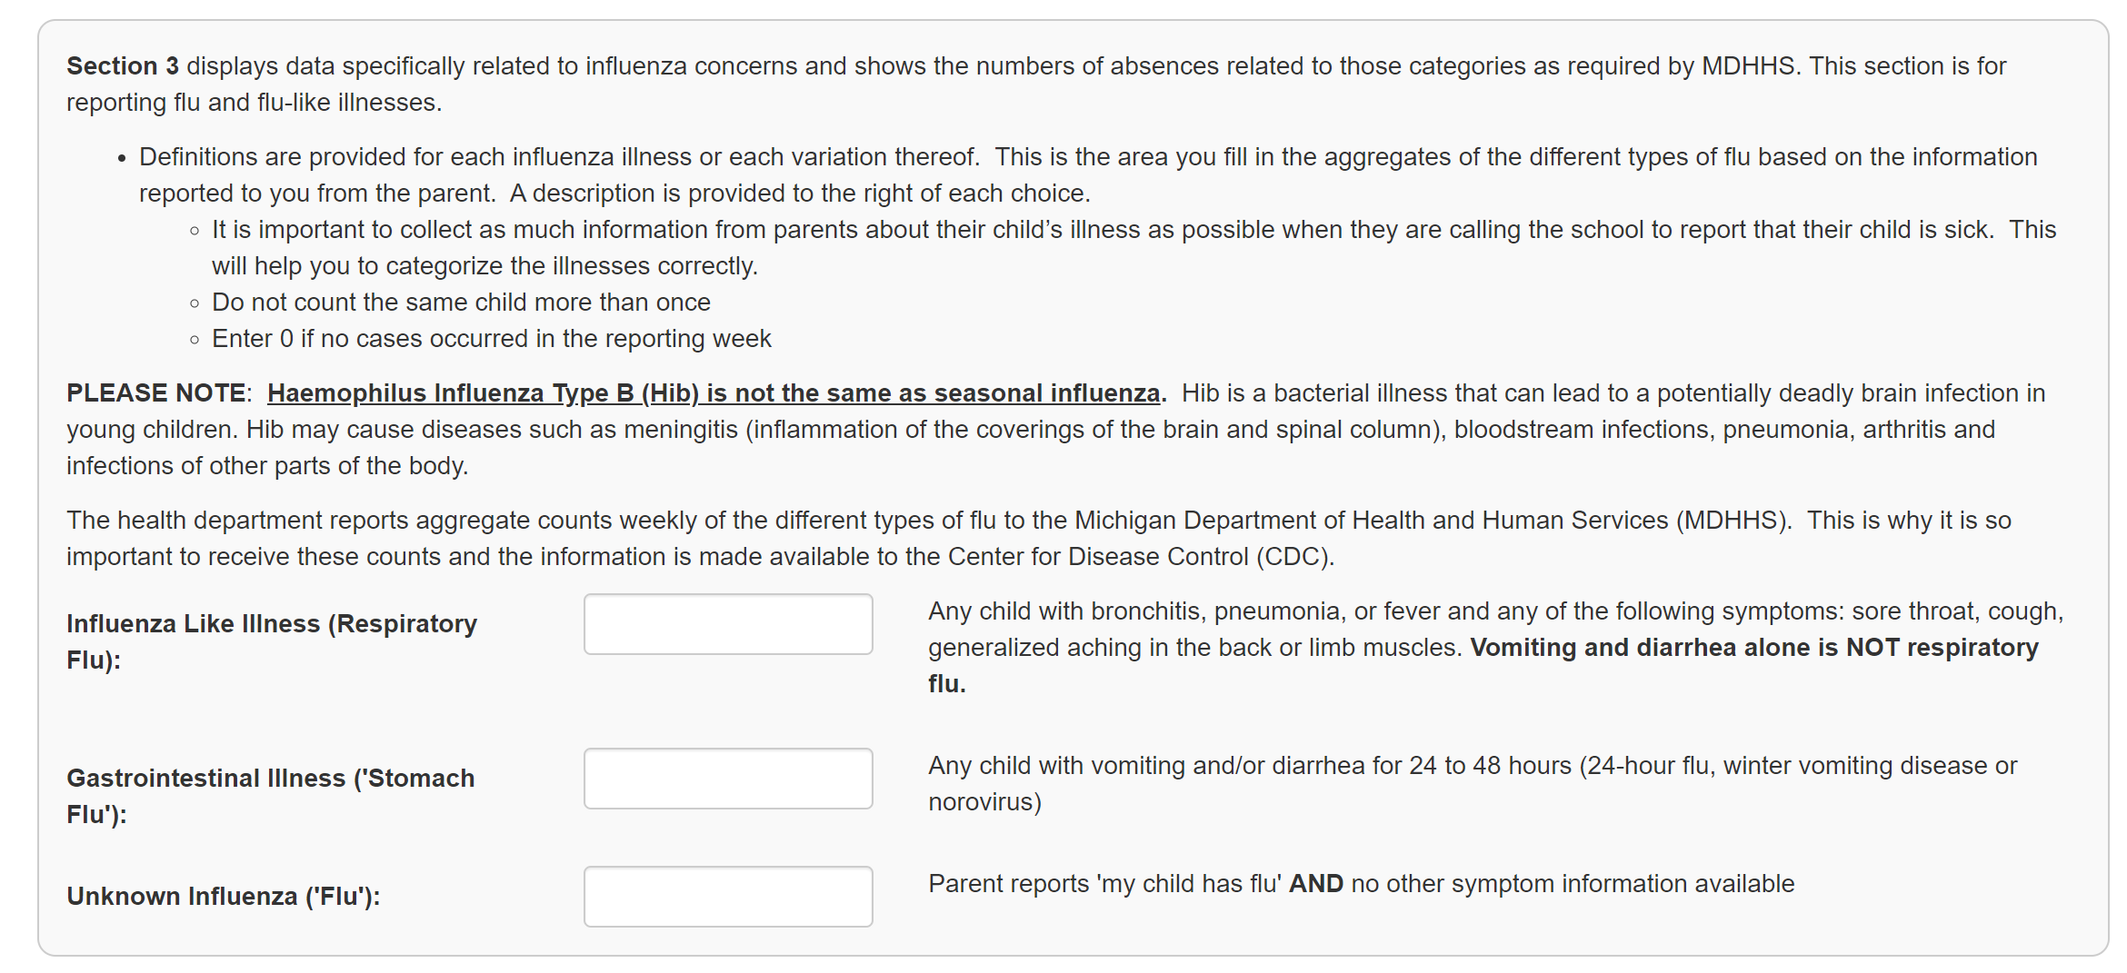
- Section 3 displays data specifically related to influenza concerns and shows the numbers of absences related to those categories as required by MDHHS. This section is for reporting flu and flu-like illnesses.
  - Definitions are provided for each influenza illness or each variation thereof. This is the area you fill in the aggregates of the different types of flu based on the information reported to you from the parent. A description is provided to the right of each choice.
    - It is important to collect as much information from parents about their child’s illness as possible when they are calling the school to report that their child is sick. This will help you to categorize the illnesses correctly.
Please Be Aware of the Different Types of “Flu”
Influenza-Like Illness (Respiratory Flu): Any child with fever and any of the following symptoms: sore throat, cough, generalized aching in the back or limb muscles. Vomiting and diarrhea alone are NOT respiratory flu.
Gastrointestinal Illness (Stomach Flu): Any child with vomiting and/or diarrhea for 24 to 48 hours (24-hour flu, winter vomiting disease or norovirus).
Unknown Influenza (Flu): Parent reports’ my child has the flu’ no symptom information available.
NOTE: Haemophilus Influenza Type B (Hib) is not the same as seasonal influenza. Hib is a bacterial illness that can lead to a potentially deadly brain infection in young children. Hib may cause diseases such as meningitis (inflammation of the coverings of the brain and spinal column), bloodstream infections, pneumonia, arthritis and infections of other parts of the body.
The health department reports aggregate counts weekly of the different types of flu to the Michigan Department of Health and Human Services (MDHHS). This is why it is so important to receive these counts and the information is made available to the Center for Disease Control (CDC).
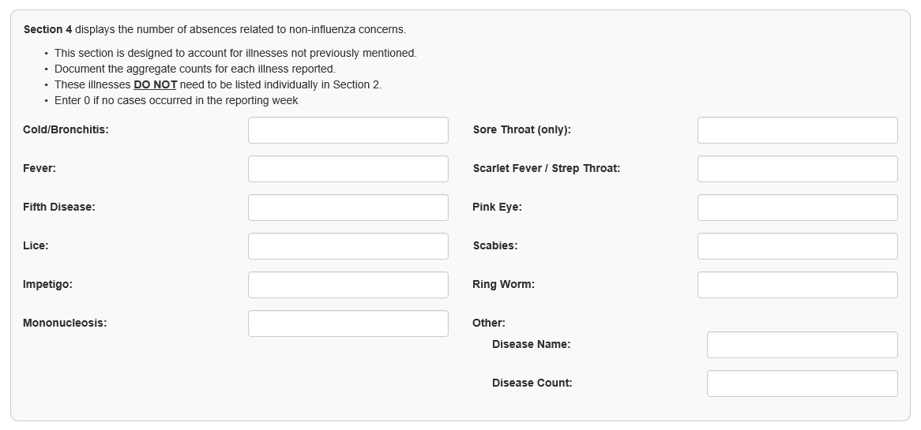
- Section 4 displays the number of absences related to non-influenza concerns.
  - This section is designed to account for illnesses not previously mentioned.
  - Document the aggregate counts for each illness reported.
  - These illnesses DO NOT need to be listed individually in Section 2.

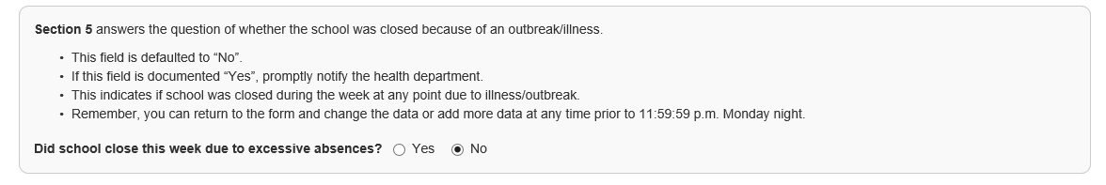
- Section 5 answers the question of whether the school was closed because of an outbreak/illness.
  - This field is defaulted to “No”.
  - If this field is documented “Yes”, promptly notify the health department.
  - This indicates if school was closed during the week at any point due to illness/outbreak.
  - Remember, you can return to the form and change the data or add more data at any time prior to 11:59:59 p.m. Monday night.
CD Reporting Deadline
The deadline for reporting each week is Friday (recommended), but by Monday at Midnight (for the previous week). However, if the online CD reporting system has not received your report by Sunday at Midnight, you will be sent an automated message to remind you to complete the report for the previous week.
If you miss the Monday at Midnight deadline, you will be unable to complete the report for the previous week. You will need to complete a Michigan School Building Weekly Communicable Disease Reporting Form and fax to the CD nurse for your county. The CD nurse will complete the online report for you and you will receive credit for completing the previous week’s report.
Remember that every Monday you will see two reporting links: one for the previous week and for the current week. Be sure to select the correct date for the week you are submitting the data. After the Monday at Midnight deadline, you will only see the current week’s link and you will no longer be able to submit the previous week’s reporting data.

Ways to Report Cont.
Fax Form for Reporting
- A copy of the Michigan School Building Weekly Communicable Disease Reporting Form is available at https://www.mmdhd.org/clinic/cd-program/ for each of the three counties.
  - This reporting method may also be helpful if the designated school CD reporter is not available to complete the online report and another staff person can complete the report
    - or if you miss the online reporting deadline (11:59:59 p.m. on Monday night).
  - This form is designed like the online reporting form.
General Information (Section 1)
- Indicate week ending date* Always a Friday even if school ends on a different day that week
- Indicate School District & School/Pre-School/Daycare
- Telephone Number
- enrollment
- Submitted by (name of person submitting report)
- Check if Nothing to Report
Serious Communicable Disease (Section 2) *Call the Health Department to speak to a communicable disease nurse if ANY of the listed “List of Reportable Diseases” is reported to your school.
Enter Aggregate #’s of Suspected Flu (Section 3)
- Do not count the same child more than once
- Enter 0 if no cases occurred in the previous week
Aggregate Numbers Other (Section 4)
- Complete each field
- Enter 0 if no cases occurred in the previous week
Did School close this week due to excessive absences? (Section 5) Indicate yes or no
Call the Health Department to speak to a communicable disease nurse if the school is closed due to illness.
Fax Numbers
Clinton County 989-227-3126 Gratiot County 989-875-1032 Montcalm County 989-831-3666
Guidelines for Readmission to Daycare and Schools for Common Childhood Illness
CHICKENPOX (Varicella) | Until lesions are dry and crusted
CONJUNCTIVITIS (Pink Eye) | Exclude until 24 hours of treatment or symptoms resolved
COVID-19 | Until isolation or quarantine is completed
DIARRHEA: Non-specific, Rotavirus  and most Salmonella | Exclude when diarrhea cannot be contained or presence of fever.
SALMONELLA Typhi | Exclusion until permission from the Health Department
SHIGELLA | Exclusion until permission from the Health Department
FIFTH DISEASE (erythema infectiosum) | Exclusion not required
HAND-FOOT-MOUTH DISEASE | Exclusion not required
HEPATITIS | When asymptomatic or at discretion of the Health Department
HERPES GINGIVOSTOMATITIS | Until lesions are dry and crusted
IMPETIGO | Exclude until 24 hours of antibiotic treatment
LICE | Exclude until treatment; or if NO NITS when this is school policy
MONONUCLEOSIS | Exclusion not required
PERTUSSIS (Whooping cough) | After 5 days of treatment
RINGWORM | Exclusion not required (should be treated)
SCABIES | Until treated
STAPH INFECTION (Boils) | Lesion should be covered
STREP THROAT & SCARLET FEVER | After 24 hours of treatment
TUBERCULOSIS | Until Physician’s advice
UPPER RESPIRATORY INFECTION | When fever is gone

As a general guideline, children with fever (temp. 100.4 F or greater), vomiting, severe diarrhea, respiratory symptoms or those too sick to have meaningful school interaction should be excluded.
Note: The above table is not a complete list. Please call the health department to speak to a communicable disease nurse for additional guidance on readmission to school/daycare for diseases not included in the above table.
Contact Numbers for Information & Assistance
- To immediately report a serious illness
- For information on disease management in schools
- For reporting guidelines
- For questions about disease surveillance and disease rates
- For questions about school reporting rates
- Staff that needs to be trained in the online Communicable Disease Reporting process or trained staff needing additional assistance

Clinton Branch Office Gratiot Branch Office Montcalm Branch Office
Becky Stoddard, RN Lisa Mikesell, RN Jennifer Johnson, RN
1307 E. Townsend Rd. 151 Commerce Dr. 615 N. State St., Ste. 1
St. Johns, MI 48879 Ithaca, MI 48847 Stanton, MI 48888
Office: 989-227-3111 Office: 989-875-1019 Office: 989-831-3615
Mobile: 616-302-6435 Mobile: 616-302-6230 Mobile: 989-763-2366
Fax: 989-227-3126 Fax: 989-875-1032 Fax: 989-831-3666
Email: bstoddard@mmdhd.org Email: lmikesell@mmdhd.org Email: jjohnson@mmdhd.org
MMDHD 24-7 Pager 989-276-0260
Additional Resources
Jennifer Morse, MD, MPH, FAAFP Dena Kent, RN BSN
Medical Director CHED Supervisor
Central Michigan District Health Department Mid-Michigan District Health Department
Mid-Michigan District Health Department Office: 989-831-3609
District Health Department #10 Mobile: 616-302-6768
Mobile: 989-802-2590 Email: dkent@mmdhd.org
Office: 989-773-5921, ext. 1427
Email: jmorse@cmdhd.org

Mid-Michigan District Health Department
www.mmdhd.org
For immunization information visit:
MCIR
www.mcir.org
MDHHS
www.michigan.gov/immunize
For communicable disease information visit:
Michigan Department of Health and Human Services (MDHHS) Communicable Diseases A-Z
http://www.michigan.gov/mdhhs/0,5885,7-339-71550_5104_53072_53073---,00.html
Centers for Disease Control and Prevention (CDC)
http://www.cdc.gov/DiseasesConditions/index.html
MDHHS: Head Lice Manual
http://www.michigan.gov/documents/Final_Michigan_Head_Lice_Manual_106828_7.pdf
MDHHS: Influenza information for Schools and Childcare Settings
http://www.michigan.gov/mdch/0,1607,7-132-2940_2955_22779_40563_48357-199676--,00.html
MDHHS: Scabies Prevention and Control Manual
http://www.michigan.gov/documents/scabies_manual_130866_7.pdf
Michigan Manual for the Control and Prevention of Bed Bugs
https://www.michigan.gov/documents/emergingdiseases/Bed_Bug_Manual_v1_full_reduce_326605_7.pdf
Managing Communicable Diseases in Child Care Settings https://www.michigan.gov/documents/lara/lara_BCAL-PUB-0111_0715_494233_7.pdf
Michigan Department of Education and Michigan Department of Health and Human Services, Divisions of Communicable Disease & Immunization (May 2018) Managing Communicable Diseases in Schools https://www.michigan.gov/documents/mdch/Managing_CD_in_Schools_FINAL_469824_7.PDF
COVID-19 School Resources
https://www.mmdhd.org/covid-schools/

Parent Notification Letters
Parent notification letters are available upon request to the school building/districts for most commonly reported illnesses. If you are requesting a letter for distribution contact the communicable disease nurse in your county. If the nurse is not available in your county you may contact a communicable disease nurse in another county. These letters are an additional resource school districts may wish to utilize, but not a requirement to distribute because a case was reported

